**Observations and Inferences**

1. Classify the observations as quantitative or qualitative, by putting them in the correct column in the table.

* 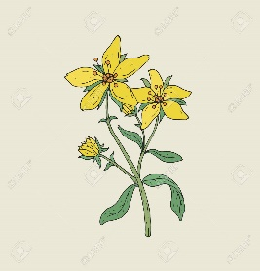The tree has green leaves
* The water is hot
* The tree is 12m tall
* The water is 75°C
* There are 3 flowers on the plant
* The flowers on the plant are yellow
* The rock sample contained 25g of quartz
* The rock sample is red, brown, and white

|  |  |
| --- | --- |
| **Quantitative** | **Qualitative** |
|  |  |
|  |  |
|  |  |
|  |  |

1. 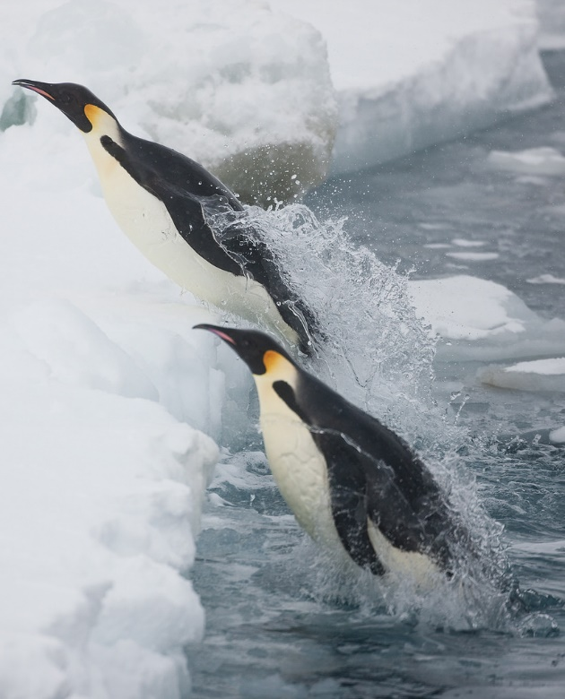Look at the picture of the penguins. Classify each statement as an observation or an inference.

__ There are two penguins

__ There are more penguins under the water

__ The penguins have black and white feathers

__ The penguins are jumping out of the water

__ The penguin’s feathers are waterproof

__ The penguins are being chased by a predator

__ The penguins live in a cold climate

__ The penguin’s habitat is water, ice and snow

1. Read the situations carefully and underline the observation in red and the inference in blue.
   1. There are many puddles on the ground, so it must have rained.
   2. The people down the street must be having a barbecue because the air smells like smoke and cooking meat.
   3. There is a baseball in my driveway and my car windshield is broken. Someone playing ball must have shattered my windshield.
2. Read the following observations, then make an inference that explains each observation. There may be more than one inference for an observation.

Observation 1: You observe that the sky is getting dark at noon.

Inference: _______________________________________________________________

Observation 2: There are a lot of people at the swimming pool.

Inference: _______________________________________________________________

Observation 3: A child is crying after they fell over.

Inference: _______________________________________________________________

Observation 4: A former rock band member has poor hearing.

Inference: _______________________________________________________________

Observation 5: You leave the cinema and see that the street is wet.

Inference: _______________________________________________________________

Observation 6: During a handshake, you notice the person’s hand has blisters.

Inference: _______________________________________________________________

Observation 7: The house lights are off.

Inference: _______________________________________________________________

Observation 8: A siren is heard going past the school.

Inference: _______________________________________________________________

Observation 9: The cat climbed up the tree.

Inference: _______________________________________________________________

Observation 10: A flock of ducks flew off a lake.

Inference: _______________________________________________________________